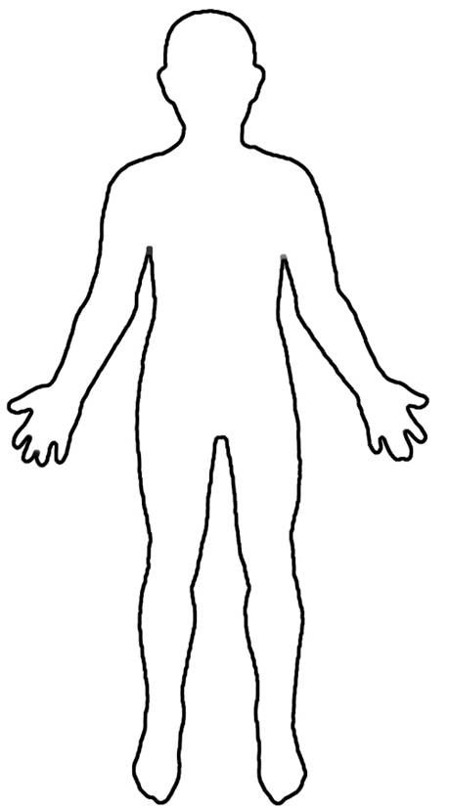
Body System Diagrams of:
Circulatory system w/veins and arteries
Digestive system
Respiration system
Immune (Lymphatic) System and Excretory Systems (combined on one Man)

Nervous System
Endocrine System/Glands

